Gender Pay Gap Extract Report

Snapshot Date: 31.03.2025

Payroll – Herefordshire, Ludlow & North Shropshire College

Hourly Rate Gaps

 |  |  | Percentage
 | Male | Female | Difference
Mean | 17.73 | 15.99 | 9.81%
Median | 17.14 | 14.08 | 17.85%

Hourly Rate Quartiles

Gender | Lower (156) |  | Lower Middle (156) |  | Upper Middle (156) |  | Upper (156)
Male | 44 | 28.2% | 35 | 22.43% | 57 | 36.54% | 71 | 45.51%
Female | 112 | 71.8% | 121 | 77.57% | 99 | 63.46% | 85 | 54.49%

Proportion of male and female employees per quartile

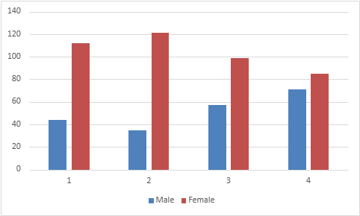

Bonus Gaps
 |  |  | Percentage
 | Male | Female | Difference
Mean | 0.00 | 0.00 | 0.00%
Median | 0.00 | 0.00 | 0.00%

Bonus Proportions
Number of Males receiving bonus: 0/207
Proportion of Males receiving bonus: 0.00%
Number of Females receiving bonus: 0/417
Proportion of Females receiving bonus: 0.00%

